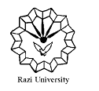
Razi University
Faculty of Chemistry
Department of Analytical Chemistry
M. S. C Seminar
Supercapacitors
materials and Applications
Supervisor:
Dr. Fahimeh jalali
Presented by:
Yeganeh abasi
2021 APril 7,wednesday
11 AM
Link : https://vc5.razi.ac.ir/rbxqzbc1bj23/?session=breezbreezuno4crir2u9us5ba&proto=true

