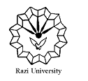
Razi University
Faculty of Chemistry
Department of Nanochemistry

Ph.D. Seminar
MXene:
Synthesis, Structures and Applications

Presented by:
Leila Ghaedrahmati

Supervisor:
Dr. Mohammad Jafarzadeh

Monday, 6 Dec. 2021
Time: 11:30 AM

Link: https://vc5.razi.ac.ir/rqfbiynyylv4

