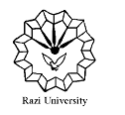
Razi University
Faculty of Chemistry
Department of Applied Chemistry

Ph.D Seminar

Microbial desalination cell

Supervisor:
Dr. Ali Akbar Zinatizadeh
Dr. Sirus Zeinaddini

Presented by:
Fariba Oulad

Saturday
October 24, 2020
2:00 PM
Faculty of Chemistry, Amphitheater

