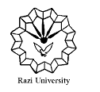
Razi University
Faculty of Chemistry
Department of Physical Chemistry
M. S. C Seminar
Ionic Liquids Applications
Supervisor:
Dr. Hamid Reza Rafiee
Presented by:
Zahra Akbari
2021 July 10, Saturday
09:30 AM
http://vc5.razi.ac.ir/rsrfk5l4w0ov/

