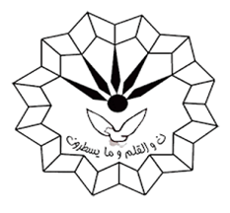
Ph.D Seminar
Department of Organic Chemistry
Faculty of Chemistry
Razi University
Presented by:
Saeed Askari
Supervisor:
Prof. Mohammad Mehdi Khodaei
Dr. Mohammad Jafarzadeh
Tuesday
2021 October 12
Time: 11 Am
post-synthetic modification (PSM) of metal-organic frameworks Toward Applications

